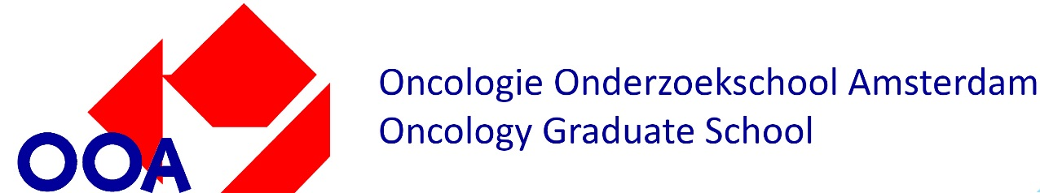

OOA Training Plan

Name PhD student:
Supervisors:
Start date PhD project:
Project title:
CCA Research theme(s): Cancer Biology, Cancer Immunology, Target & Therapy Discovery, Imaging, Biomarkers, Therapy, Supportive Care - please select max 2

This plan is compulsory voor PhD candidates who started their research after 01-01-2021. Please complete the table below with the courses and educational activities you are planning to do during your PhD training. The Training Plan consist of professional knowledge courses, general skill courses and other scientific activities. The OOA defined guidelines to create a divers and balanced training plan, suitable for each PhD student. Find the OOA training plan guidelines, further explanation and links to examples of activities and courses on page 2.

NAME COURSE, TRAINING, ACTIVITY | ORGANISER | ECTS | YEAR
PROFESSIONAL KNOWLEDGE COURSES
GENERAL SKILL COURSES
Scientific integrity/ethics course (compulsory) |  | 2 ECTS (min)
SCIENTIFIC ACTIVITITES
Attending conferences (1x compulsory)
EXEMPTION* |  | Max 2
If possible, please add hyperlinks to the courses and activities | TOTAL ECTS
Finished your training plan? Check the OOA website for the next steps in your PhD registration:
- AMC PhD students procedure
- VUmc PhD students procedure

*Motivated and substantiated exemption requests (including associated certificates) can be submitted to the OOA committee or review. Exemption will be granted if the PhD candidate has required the necessary knowledge.
OOA Training Plan guidelines

The OOA Training Plan includes a number of compulsory elements essential to every PhD candidate and a more flexible part that can be tailored to your individual needs, interests and background.
The basic criteria of all Training Plans are the same and include:
– a total number of 30 ECTS credits (1 ECTS equals 28 hours);
– a mandatory ‘Ethics and Integrity in Science’ course (min 2 ECTS);
– at least one conference visit (max 2 ECTS per visit);
– at least 8 ECTS earned in professional knowledge and general skill courses;
– the remaining credits are earned by participating in amongst others, courses, activities, retreats, conferences and (work) discussions.

Compulsory elements
Highly recommended activities & courses

PROFESSIONAL KNOWLEDGE COURSES |  | Minimum of 8 ECTS
Basics in Oncology and/or Advanced Immunology (for CCA/AII PhD candidates) | Click here for detailed information and examples
Topical courses, such as those offered by OOA
Technical courses, such as those offered by OOA
Courses offered by other institutes/ graduate schools /universities
GENERAL SKILLS COURSES
Scientific integrity/ethics course (compulsory) | Min 2 ECTS
Statistics | Click here for detailed information and examples
Soft skills
Courses obliged by law, such as BROK, animal handling
Courses offered by other institutes/ graduate schools /universities

SCIENTIFIC ACTIVITITES | Click here for detailed information and examples | #ECTS
Attending conferences (1x compulsory) | Giving a (poster)presentation, networking | Max 4
Introduction meeting institute | AMC world of Science; Introduction to CCA | Max 1
Attending OOA retreat | 2x recommended; giving a (poster)presentation; chairing sessions; discovering the whole spectrum of cancer research; networking | Max 4
Attending other retreats | CCA retreat/ AII retreat (for tumor-immunology PhD students)/ NKI retreat/department retreats | Max 4
Meet-the-expert/masterclasses/seminars | Attending and presenting during these meetings | Max 4
Staff/department/labmeetings/journal clubs | Attending and presenting during these meetings | Max 4
Institute-wide activities | CCA seminars; NKI Seminar series | Max 4
Supervision intern students | Supervision of master/bachelor student for 6-9 months | Max 6
Giving/organizing education | Organizing activity/workshop/seminar, giving lectures | Max 3
Preparing a publication | Writing a scientific article with help of supervisor | Max 2
Participating in committee | PhD candidate council; advisory committee | Max 2

TOTAL ECTS | 30

