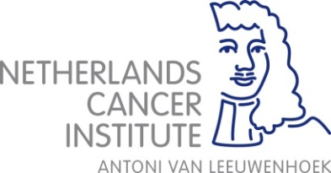

Registration form for OOA course 2017
Basic Medical Statistics (with SPSS)
November 13-17

Only for people from outside NKI and AVL. They use Leerportaal

Participant Name
Email address
Telephone number
Institute
Department
Function | PhD student / Postdoc / MD / other:
Name supervisor
SPSS introduction on Friday November 10 | Yes / No
Brings own laptop with SPSS on it | Yes / No  If no, you can use a laptop from the institute but it is possible that you have to share one
Short CV (education/research)
Wants to learn

Please fill in by typing and return the form before October 1st 2017 to
p.lagerweij@nki.nl

